**Separating Components of an Audio Signal and Reconstructing them Using Digital Signal Processing**

Shailja Agrawal, Sanskriti

Dept of Electronics Engineering

ZHCET, Aligarh Muslim University

Aligarh (202001), India

**Abstract:** This research proposes a novel approach for separating different signal components from an audio signal and reconstruct the original signal by adding the components using digital signal processing components such as Fast Fourier Transform (FFT), Inverse Fast Fourier Transform (IFFT) and windowing.

I. INTRODUCTION

Audio signal processing is an important field of research that deals with the manipulation, analysis, and interpretation of sound signals. One of the key challenges in audio signal processing is the separation of different components of a mixed audio signal, such as individual voices or musical instruments, in order to analyze or manipulate them separately.

The separation of different audio components from a mixed signal can be accomplished using various techniques, including Fourier Transform (FFT), Inverse Fast Fourier Transform (IFFT) and windowing. These techniques involve transforming the audio signal from the time domain to the frequency domain, identifying and isolating the different frequency components of the signal, and then transforming the signal back to the time domain.

In audio processing, it can be used to remove unwanted noise or to isolate specific frequency components, such as the human voice or a musical instrument, from a mixed audio signal.

In speech recognition, it can be used to isolate and analyze specific features of speech, such as formants and pitch, which can help in identifying and distinguishing different speakers.

In music analysis, it can be used to identify and analyze the different components of a musical composition, such as melody, harmony, and rhythm, which can help in understanding the structure and complexity of the music.

Overall, separating different signal components from an audio signal using FFT, IFFT, and windowing can provide valuable insights and information for various applications in the fields of audio processing, speech recognition, and music analysis.

II. METHODOLOGY

Separating the music components from an audio signal using Fast Fourier Transform (FFT) and Inverse Fourier Transform (IFT) with windowing is a widely used technique in audio signal processing. The process involves breaking down a mixed audio signal into its individual frequency components, isolating the frequency range corresponding to the music components, and then reconstructing the individual audio signals using the IFT.

First step applies a window function to the audio signal to reduce the distortion caused by the abrupt start and stop of the signal. The Hamming window is a commonly used window function that tapers the signal smoothly to zero at the beginning and end, making the signal appear more periodic and reducing spectral leakage.

The second step is processing the signal using FFT to obtain its frequency spectrum, which represents the frequency components of the audio signal. The frequency spectrum can be visualized as a plot of amplitude versus frequency.

The next step is to identify the frequency range that corresponds to the music components of the audio signal. This can be done by visual inspection of the frequency spectrum or by using prior knowledge about the music being analyzed.

It separates the guitar component from the audio signal by filtering out frequencies from **2-500 Hz**, the drum component by filtering out frequencies from **5000 to 6000 Hz**, and the human voice component by filtering out frequencies from **1500-2500 Hz**. Each music component is saved in separate audio files.

Once the music component frequency range is identified, all other frequency components outside the range of interest are zeroed out, leaving only the music components. This modified frequency spectrum is then processed using IFT to obtain the time-domain music signal.

By repeating this process for different frequency ranges corresponding to different instruments or vocals in the audio signal, the final separated music components can be obtained.

Finally, we reconstruct the audio signal by adding the separated music components and saves the reconstructed signal to an audio file. The reconstructed signal is also plotted for visualization.

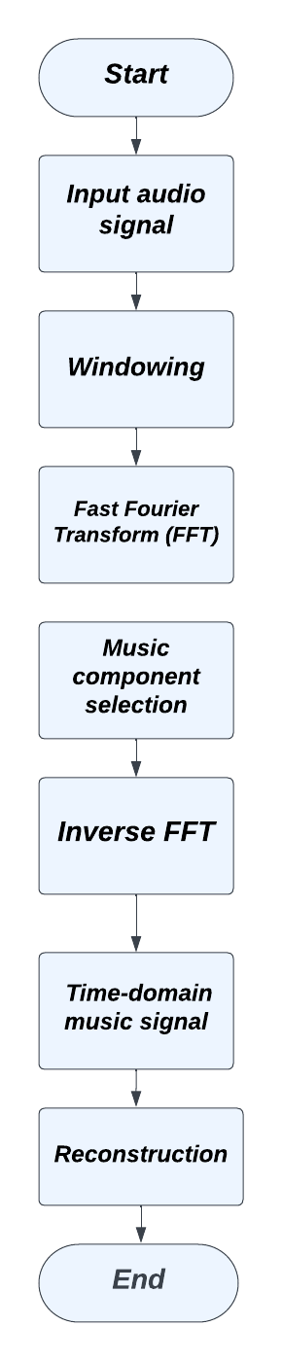

**Fig 1:** Block Diagram of the extraction of different components and reconstructing them

In summary, the process of separating music components from an audio signal using FFT and IFT with windowing involves breaking down the audio signal into individual frequency components, selecting the frequency range that corresponds to the music components, and reconstructing the individual audio signals. This technique is

widely used in music production, audio engineering, and music research applications.

III. TOOLS USED

Different signal processing tools is being used such as Fast Fourier Transform (FFT), Inverse Fast Fourier Transform (IFFT) and

Windowing.

1. **FAST FOURIER TRANSFORM**

FFT stands for Fast Fourier Transform, which is a widely used algorithm for computing the Discrete Fourier Transform (DFT) of a sequence, such as a signal or an image. The DFT is a transformation that converts a sequence from its time-domain representation to its frequency-domain representation. The result of the DFT is a complex-valued sequence that describes the frequency content of the input sequence.

FFT is a faster way of computing the DFT than the standard algorithm. The FFT algorithm works by recursively breaking down the input sequence into smaller and smaller sub-sequences, and then combining the results to obtain the final DFT.

FFT has many applications in signal processing, such as filtering, spectral analysis, and data compression. It is used in many fields, including audio and video processing, communications, and scientific computing.

1. **INVERSE FAST FOURIER TRANSFORM**

IFFT stands for Inverse Fast Fourier Transform. It is the reverse operation of the Fast Fourier Transform (FFT). While FFT is used to convert time-domain signals to the frequency domain, IFFT is used to convert frequency-domain signals back to the time-domain.

In other words, IFFT can be used to recover the original signal from its Fourier transform. This is done by computing the IFFT of the Fourier transform, which results in a time-domain signal that is equivalent to the original signal.

IFFT is widely used in signal processing applications, such as digital signal processing, audio and video compression, and image processing. It is also used in scientific research, such as in the analysis of astronomical data, where it is used to recover time-domain signals from their Fourier transforms.

1. **HAMMING WINDOW**

Hamming window is a commonly used window function in signal processing that is used to reduce the spectral leakage in Fourier analysis. A window function is a mathematical function that is applied to a signal before performing Fourier analysis to reduce the unwanted effects caused by the finite length of the signal.

The Hamming window is defined as:

**w(n) = 0.54 - 0.46cos(2pi*n/N),**

**0 <= n <= N-1**

where N is the length of the window and n is the index of the sample in the window. The Hamming window is a symmetric function that tapers the edges of the signal towards zero, while preserving the center portion of the signal. This reduces the spectralleakage caused by the discontinuities at the edges of the signal.

The Hamming window has a smooth transition between the windowed signal and the zero-padded edges of the window. This reduces the side lobes in the frequency spectrum and improves the accuracy of the spectral analysis.

The Hamming window is widely used in various applications of signal processing, such as audio and image processing, spectral analysis, and filtering. It is one of the most popular window functions due to its simple implementation, good performance, and low computational cost.

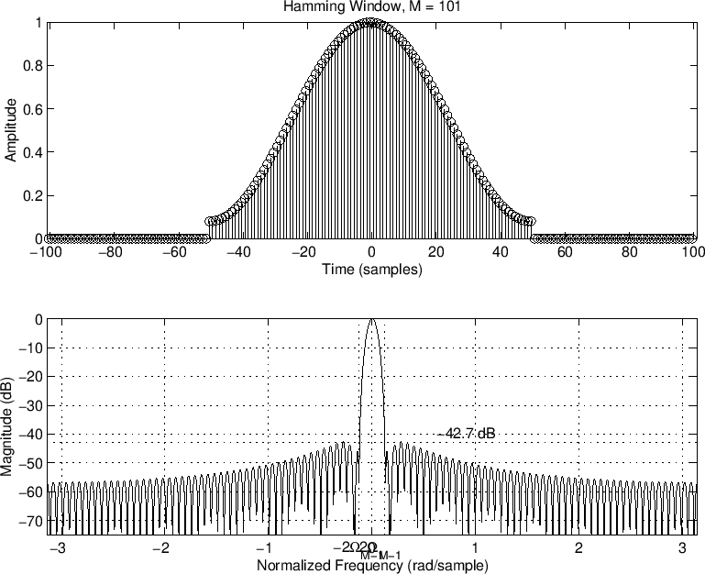

**Fig 2**: Hamming Window

IV. RESULT

We have successfully separated the different components from audio signal.

Output result images are being attached.

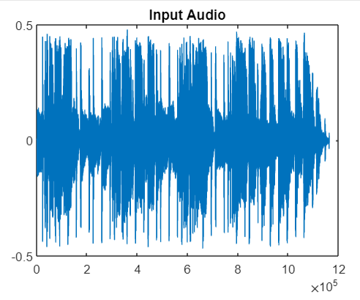

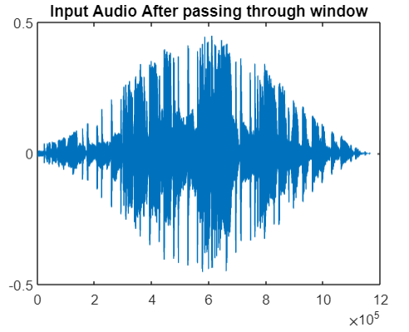

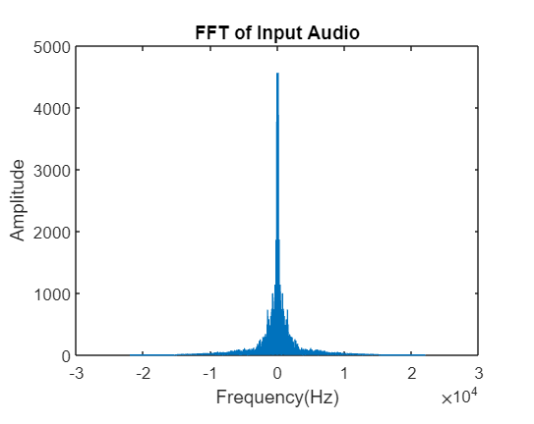

**Fig 4:** Different Components of audio signal

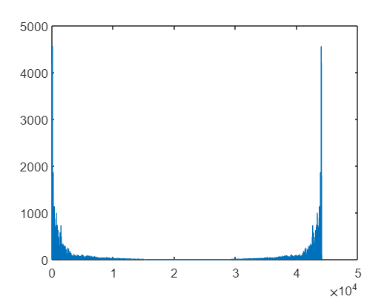

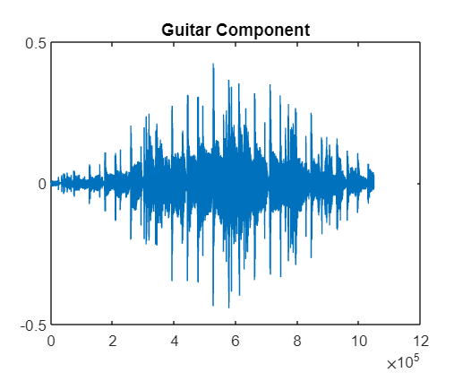

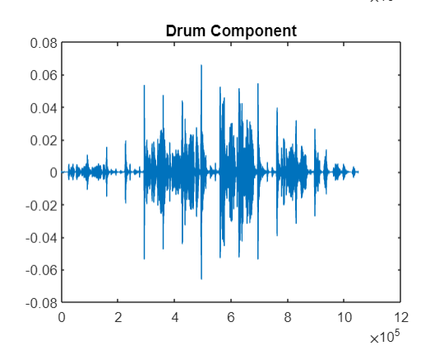

**Fig 5:** Reconstructed Audio Signal

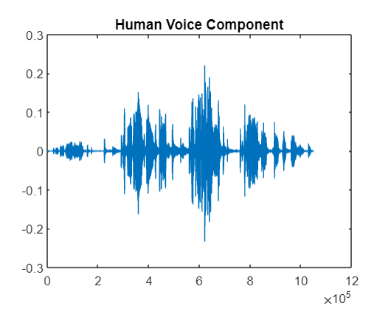

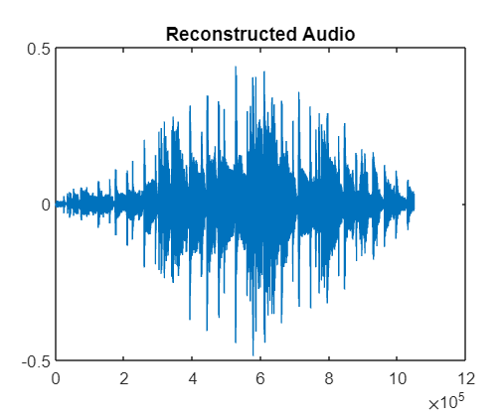

V. DISCUSSION

In this experiment we have successfully separated the different components of audio signal. After this we have combined these components to obtain the reconstructed signal.

The separation of different audio components from a mixed signal is a challenging problem in audio signal processing, as it requires accurately identifying and isolating the various frequency components of the signal. The techniques for achieving this separation, such as FFT, IFFT, and windowing, have been widely used and have undergone significant development over the years.

Applications of this research can be found in a wide range of fields. In speech recognition, separating different components of speech signals can improve the accuracy of automatic speech recognition systems. In music analysis, separating different musical components can provide valuable insights into the structure and complexity of musical compositions. In audio processing, the separation of different components can improve the quality of audio signals, such as removing noise from speech signals or isolating specific frequency components in music signals.

One major challenge in this field is the trade-off between accuracy and efficiency. While more accurate methods exist, they may be computationally intensive and may not be suitable for real-time applications. On the other hand, simpler and more efficient methods may sacrifice accuracy.

VI. CONCLUSION

As technology continues to advance, there are several future directions for research in this field. For example, the development of new hardware and software tools can enable more efficient and accurate separation of different audio components. Additionally, the integration of other types of data, such as visual or textual information, can provide additional context for separating different audio components.

REFERENCES

* <https://www.google.com/search?q=hamming+window&sxsrf=APwXEdecv8_LSwW4H572Ed1pP0tETDLoBQ:1682793083913&source=lnms&tbm=isch&sa=X&ved=2ahUKEwjAyPzf3M_-AhWXR2wGHZ-PAY8Q_AUoAXoECAEQAw&biw=1536&bih=714&dpr=1.25#imgrc=7zZKh6jMtfe5iM>
* <https://www.sciencedirect.com/science/article/pii/S101836391830850X>

APPENDICES

Code:

<https://drive.google.com/drive/folders/1k6WN8XvZg629Dm1lX__LQjREc58tby5U?usp=sharing>